**socket programming project**

3784 – 3381 - 3345

Over-all function

In this project we’re supposed to implement client and server sides and make them communicate, talk and transfer files with each other using socket programming. We’re using TCP connection and IPv4.

Our code is divided into two main parts or functionality. 1st is the “POST” functionality and the 2nd is the get one.

POST is used to upload a file to the server from a client side.

GET is used to download a file from the server side.

Client has a command line interface that type just 2 distinct a POST or GET function stating the filename and the method.

Basically, we’re using Python Jupiter notebook for coding as It provided us with some simplicity.

Client:

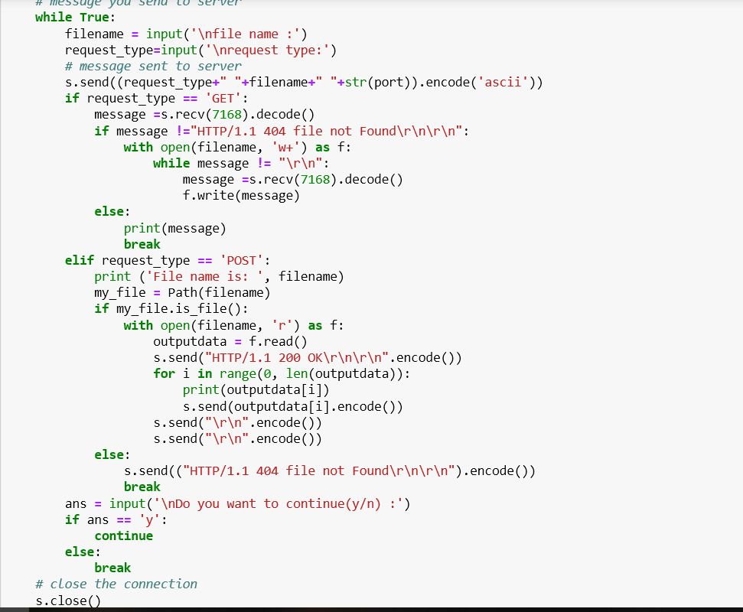Here if the client is POSTing then it shall send the server the file name in something like a header then ack the connection sending 200 OK message. Afterwards it shall send the file stated followed by a carriage return and a line feed.

On the other hand while GETting a file. The client is waiting for a the file from the server so he is inside an infinite loop till it receives the \r\n.

On both cases, if file is not found then a 404 ERR is sent to the concerned side.

Server:

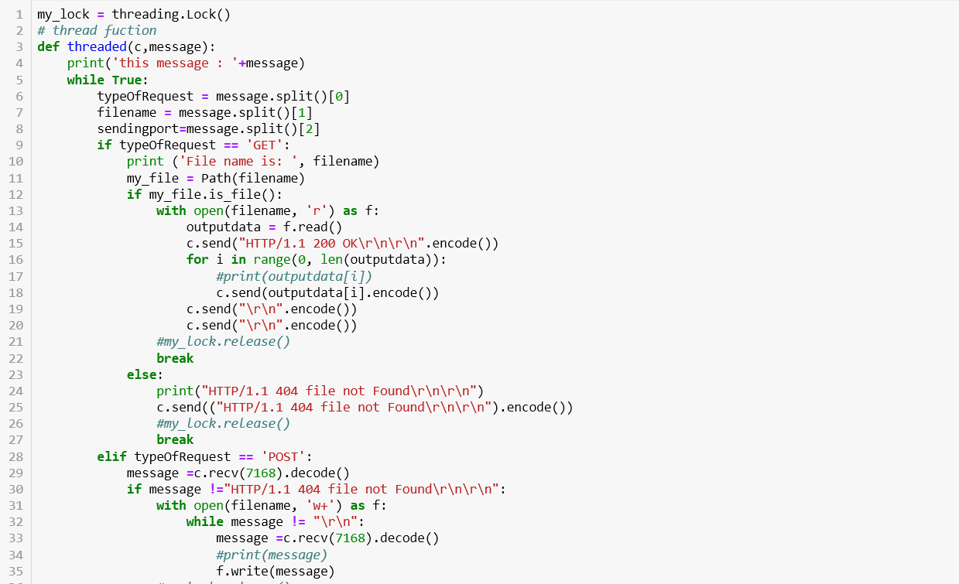

Similarly, the server has same 2 parts of the GET and POST with inverse functionality of the client side.

Since the server is the one who handles the threading part, it has the threading function and hence locks and the imports of threading.

There’s no special data structure used. Python is flexible with variables and buffering so we have not needed a special purpose data structure. Just normal variables for buffering and processing.

Help links:  
https://www.geeksforgeeks.org/socket-programming-multi-threading-python/